Q1. Write a java program to print Student Information

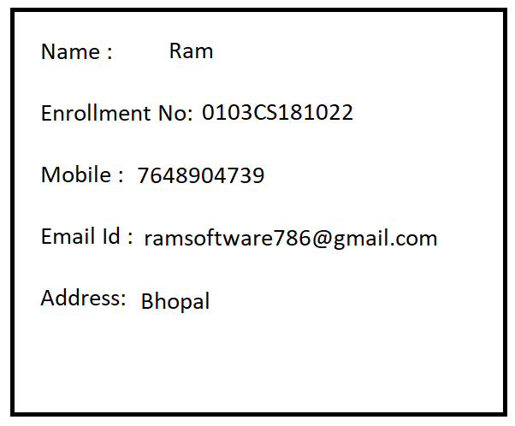

Q2. Explain Data type in java programming?

Ans: Data type can specify what type data can be store and how many bytes memory could be allocated.

Types of Data types

1. Primitive Data type: such as int,char,float,double,boolean
2. Non Primitive: Such as String,Array

Types of Data type

1. Pre-defined Data type: int,char,float,double,boolean
2. User-Defined Data type: using class
3. int : if we want to store a whole number then we should go for int data type.

Example: age,rollno,sno, hno,pincode

Size : 4 byte

Format specifier : %d

1. float: if we want to store a real number upto 6 decimal places then we should go for float data type

Example: percentage, average

Size : 4 byte

Format specifier : %f

Literals: f or F

1. double: if we want to store a real number upto 15 decimal places then we should go for double data type

Example: percentage, average

Size : 8 byte

Format specifier : %f

Literals: d or D

1. char: if we want to store a alphabet then we should go for character data type

Example: grade, gender, section

Size : 2 byte

Format Specifier: %c

Literals: ‘ ’

1. boolean: It is used to store true and false value

Example: to store result of condition

Non-Primitive Data type:

1. String: it is a Pre-defined immutable class present in java.lang package
2. It is used to store multiple character or alphanumeric value

Format Specifier: %s

Literals: “ ”

Q3. Explain Variables in java programming?

Ans:

1. Variable is a temporary memory location it is used to store a value.
2. Value of variable may be changed during execution of the program
3. Variable must be declare before using it
4. Variable must be initialized before using it.

How to declare variable in java programming: Declaration of the variable is nothing but this is to inform the compiler

Step1:

Syntax:

Data type variable_name;

int n1;

int n2;

int n3;

Step2:

How to initialize variable in java

LHS=RHS;

LHS must be a variable

RHS may be constant, variable, expression

n1=10;

n2=20;

Step3: Operations

n3=n1+n2;

Step4: print value of Result variable

System.out.println(“Message ”+variable);

System.out.println(variable);

OR

System.out.print(“Message ”+variable);

System.out.print(variable);

OR

System.out.printf(“Message Format Specifier”,variable);

System.out.printf(“Format Specifier”,variable);

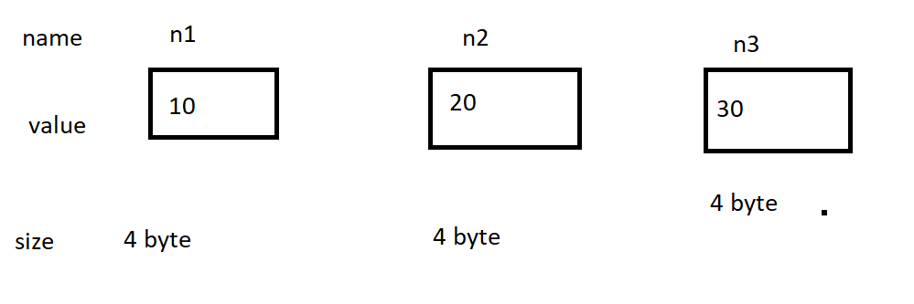

Q4. Write a java program to print sum of two numbers.

